

Air University, Islamabad

Full-Stack Lab Report # 04

Submitted To:
Instructor: Mam Fizza Asmat

Submitted By:
Student Name: Muhammad Ahmad Shafique
Student ID: 241829
Class: BSCS-V-C

04/10/2026

Table of Contents
1. Student Result Dashboard 3
Main Dashboard Overview 3
Interactive Filtering 4
Interactive Search 5
Developer Console Output (Hoisting & Loops) 6
2. Warm-Up Tasks 7
Updated Student Data & Grade Logs (Tasks 1 & 2) 7
Loops & Array Filtering (Tasks 3 & 4) 8
3. Online Bookstore Case Study 9
Initial Bookstore Catalog UI 9
Batch Order Processing & Confirmation (Tasks 2, 3 & 4) 10
Low-Stock & Category Report (Task 5) 11
4. Conclusion 13

1. Student Result Dashboard

Main Dashboard Overview
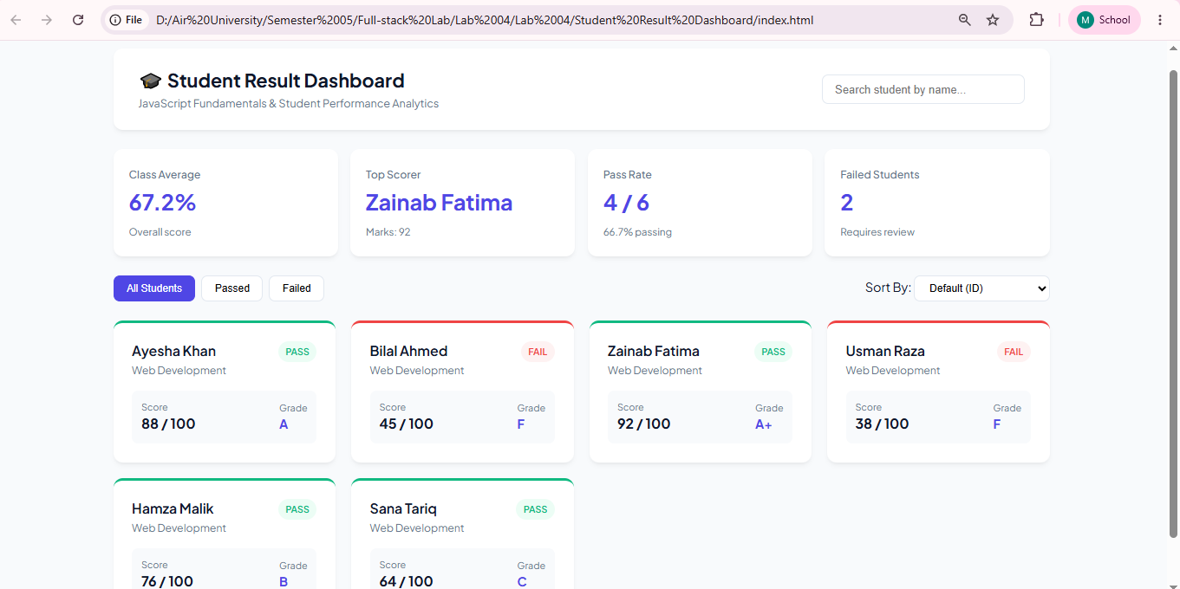
Explanation:
- Displays the overall class dashboard layout including title, search input, and summary stat cards for class average, top scorer, pass rate, and fail count.
- Demonstrates data modeling using an array of student objects as the single source of truth for rendering student cards.
- Highlights variable declaration usage with const for fixed values and let for state variables updated by user interaction.

Interactive Filtering
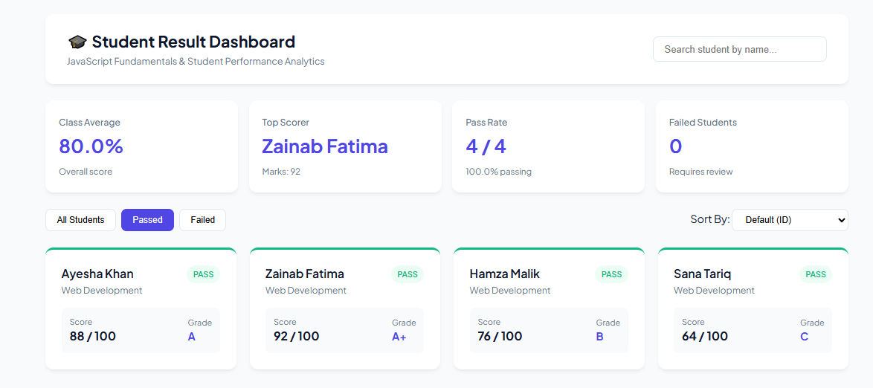
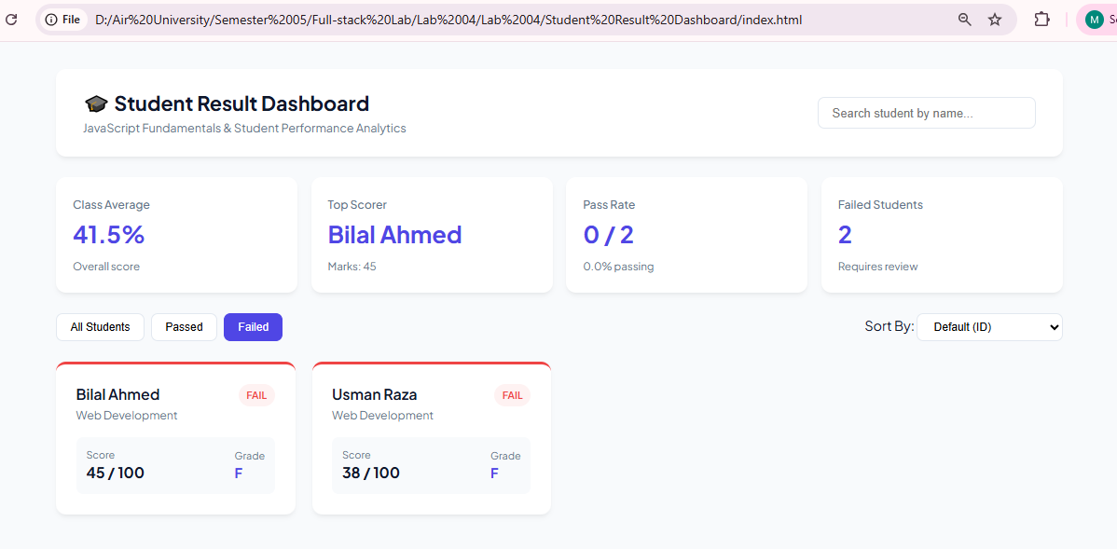
Explanation:
- Demonstrates status filtering when clicking the "Passed", "Failed", or "All Students" filter buttons.
- Applies array filter() to evaluate each student's getStatus() method and isolate pass vs. fail records.
- Dynamically updates the UI card grid and re-computes overall performance statistics using reduce() for the selected filter view.

Interactive Search
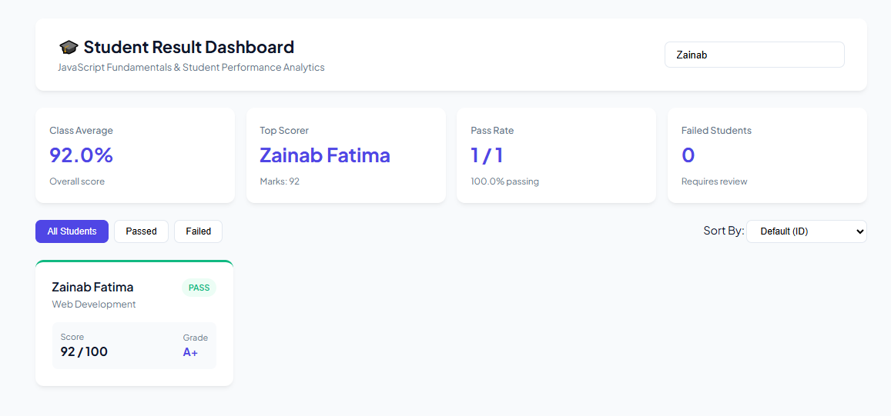
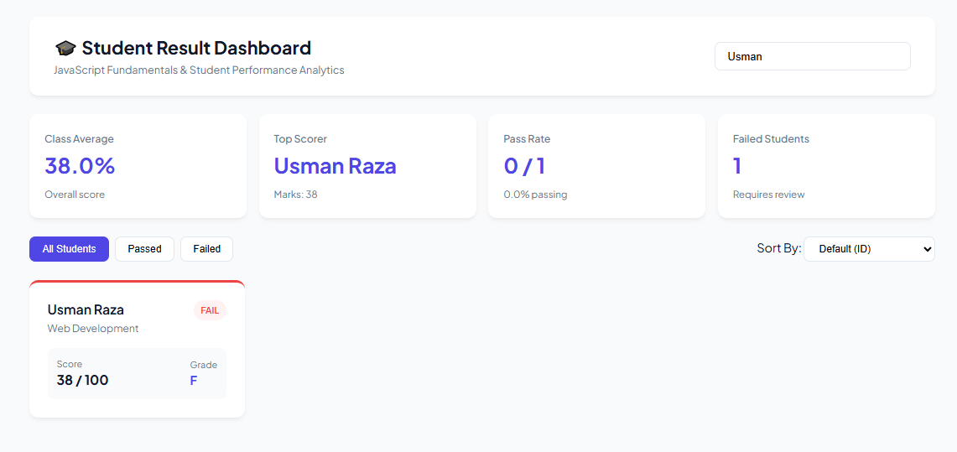
Explanation:
- Captures real-time DOM updates triggered as the user types into the search input box.
- Uses toLowerCase() and includes() inside an array filter() method to dynamically match student names against the entered search query.
- Recalculates summary metrics (class average, top scorer, pass/fail counts) based specifically on the matching search results.

Developer Console Output (Hoisting & Loops)
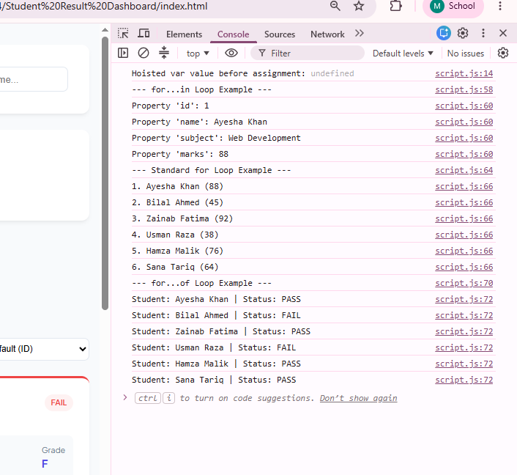
Explanation:
- Verifies variable hoisting behavior in the browser console, showing undefined when reading a var before declaration.
- Demonstrates object iteration using a for...in loop to list student object properties in the console.
- Displays sequential array iteration outputs generated using classic for and for...of loops.

2. Warm-Up Tasks

Updated Student Data & Grade Logs (Tasks 1 & 2)
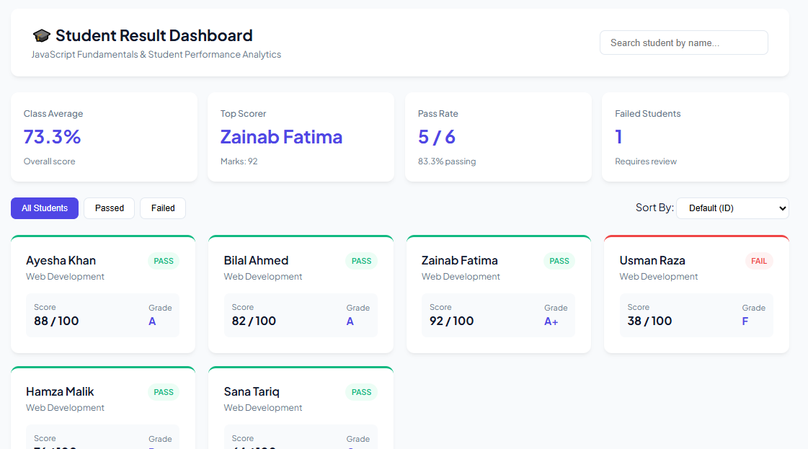

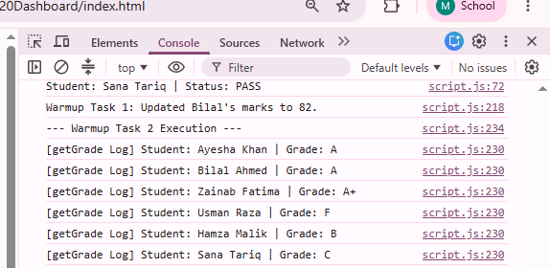

Explanation:
- Confirms Task 1 by displaying updated marks for a student in studentsData, triggering dynamic UI updates on cards and summary stats.
- Confirms Task 2 by displaying console logs generated from getGrade(), printing the calculated letter grade once per student.
- Demonstrates conditional logic (if...else if...else) executing across student performance metrics.

Loops & Array Filtering (Tasks 3 & 4)
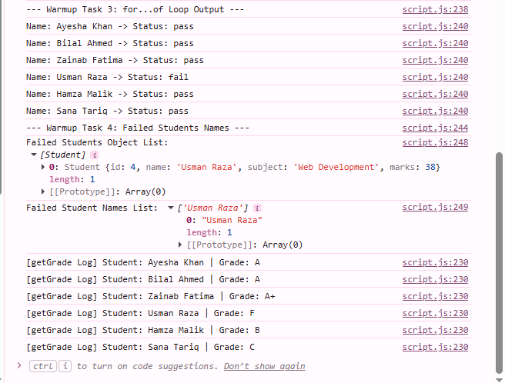
Explanation:
- Confirms Task 3 by executing a for...of loop that prints each student's name alongside their pass/fail status in the console.
- Confirms Task 4 by applying filter() to extract failed student objects and map() to return an array containing only their names.
- Verifies functional array operations and iteration without manual looping side effects.

3. Online Bookstore Case Study

Initial Bookstore Catalog UI
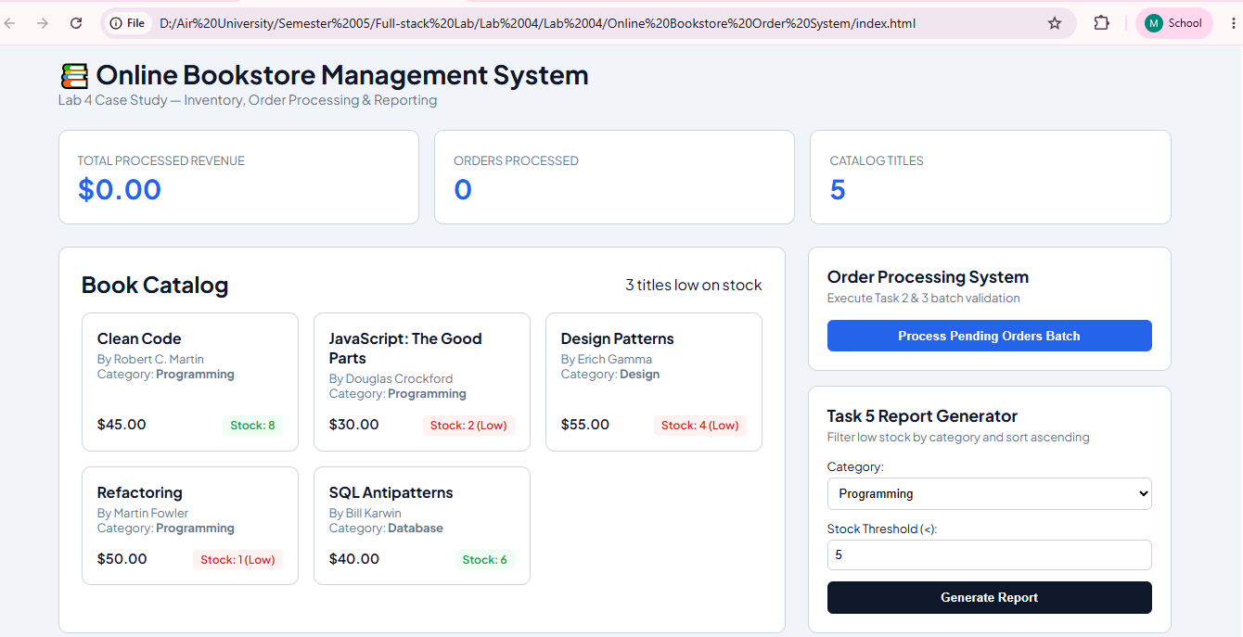

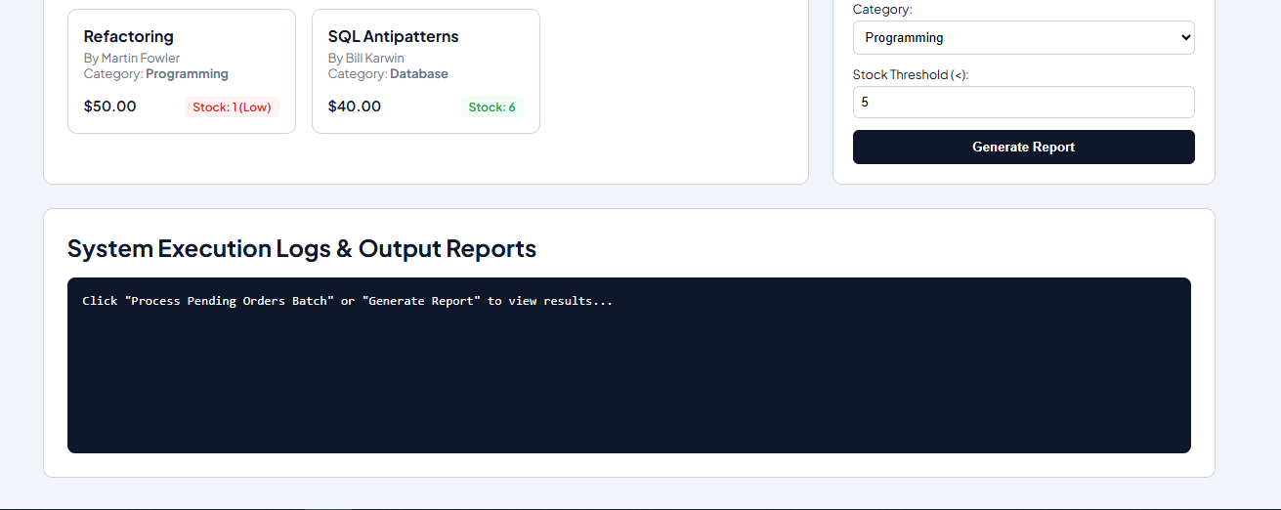

Explanation:
- Demonstrates Task 1 by rendering book catalog items from an array of Book class instances containing title, author, price, stock, and category.
- Features explicit variable declarations (const, let, var) with accompanying code comments explaining chosen scopes.
- Demonstrates Task 4 by using the Book class isLowStock() method and a ternary operator to render low-stock status badges.

Batch Order Processing & Confirmation (Tasks 2, 3 & 4)
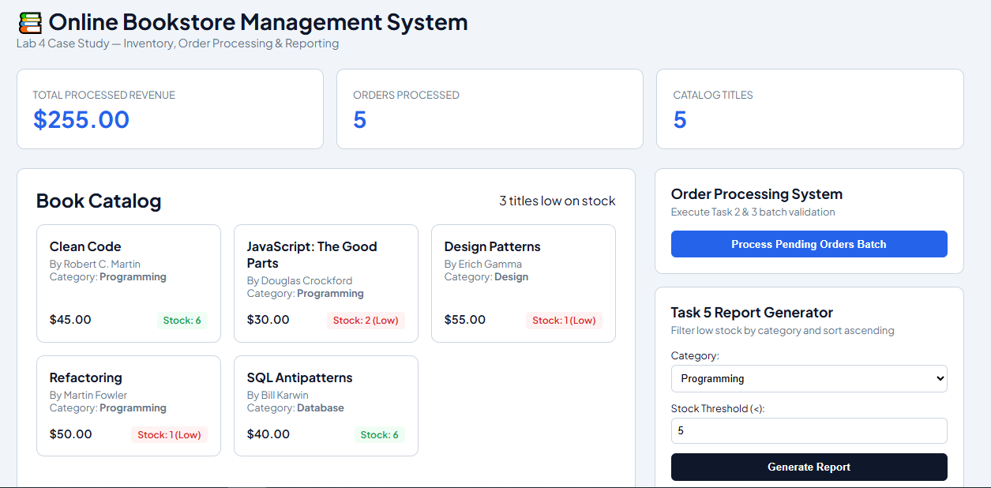

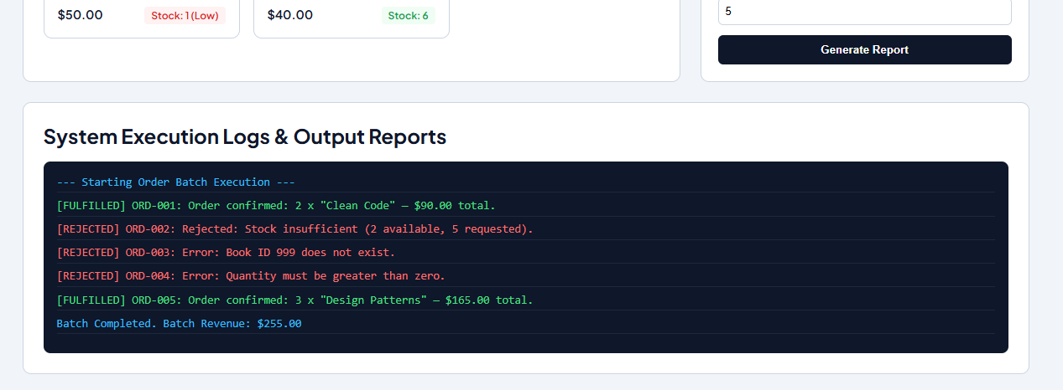
Explanation:
- Demonstrates Task 2 order validation by testing stock sufficiency, quantity values, and book existence without throwing runtime errors.
- Demonstrates Task 3 batch order processing using a for...of loop to deduct stock for valid orders and reduce() to sum total revenue from fulfilled orders.
- Demonstrates Task 4 by formatting confirmation logs using object destructuring to extract book properties and template literals for string output.

Low-Stock & Category Report (Task 5)
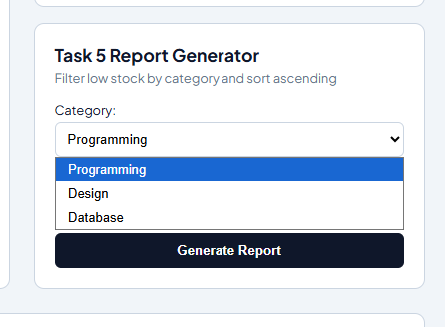
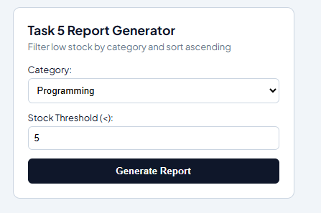
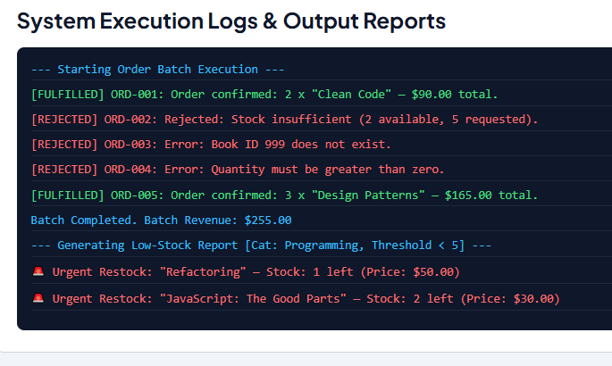
Explanation:
- Combines array filter() with logical AND (&&) conditions to extract books matching a target category with stock below a given threshold.
- Applies array sort() with a comparator (a.stock - b.stock) to order low-stock books in ascending order.
- Displays formatted output logs verifying multi-criteria filtering and restocking prioritization.

4. Conclusion
In this lab, I got hands-on experience applying fundamental JavaScript concepts—starting from basic syntax, variable scoping (var, let, const), and hoisting to ES6 features and array methods. Building the Student Result Dashboard helped me practice DOM updates, dynamic search/filter logic, and standard iteration loops (for, for...in, for...of, forEach).
When working on the Online Bookstore Order System, I designed custom classes, implemented safe order validation, and processed batch operations using .map(), .filter(), .reduce(), and .sort(). Overall, this lab helped me understand how to combine object-oriented structures, array operations, and dynamic UI rendering to build responsive, real-world web applications.

